1.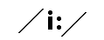
idiot
mean
lip
breakfast
2. 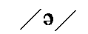
easy
enter
locked
adding
3. 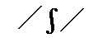
church
think
wish
vision
4. 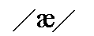
aardvark
weight
apple
hare
5. 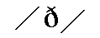
this
through
udder
dense
6. 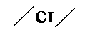
wait
either
ample
sapling
7. 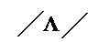
shoe
should
moon
puppy
8. 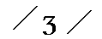
shout
wish
change
leisure
9. 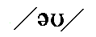
row (argument)
sow (pig)
now
row (a boat)
10. 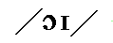
ought
should
house
annoy
11. 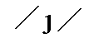
jet
German
bay
yet

12. 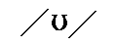
wood
mood
mop
using
